APPENDIX
IMPORTANT: the text in red SHOULD NOT be included in the design, they are instructions to guide your layout.
The Packaging Structure & Package Design must include the following requirements, elements and text. You may include additional text, images and elements

TASK 1
Create a legend for Dieline (Cut Line, Fold Line and Glue Area)
Cut Line: (The Legend)
Fold Line: (The Legend)
Glue Area: (The Legend)

TASK 2
Brand logo: (Chockies Logo Template)
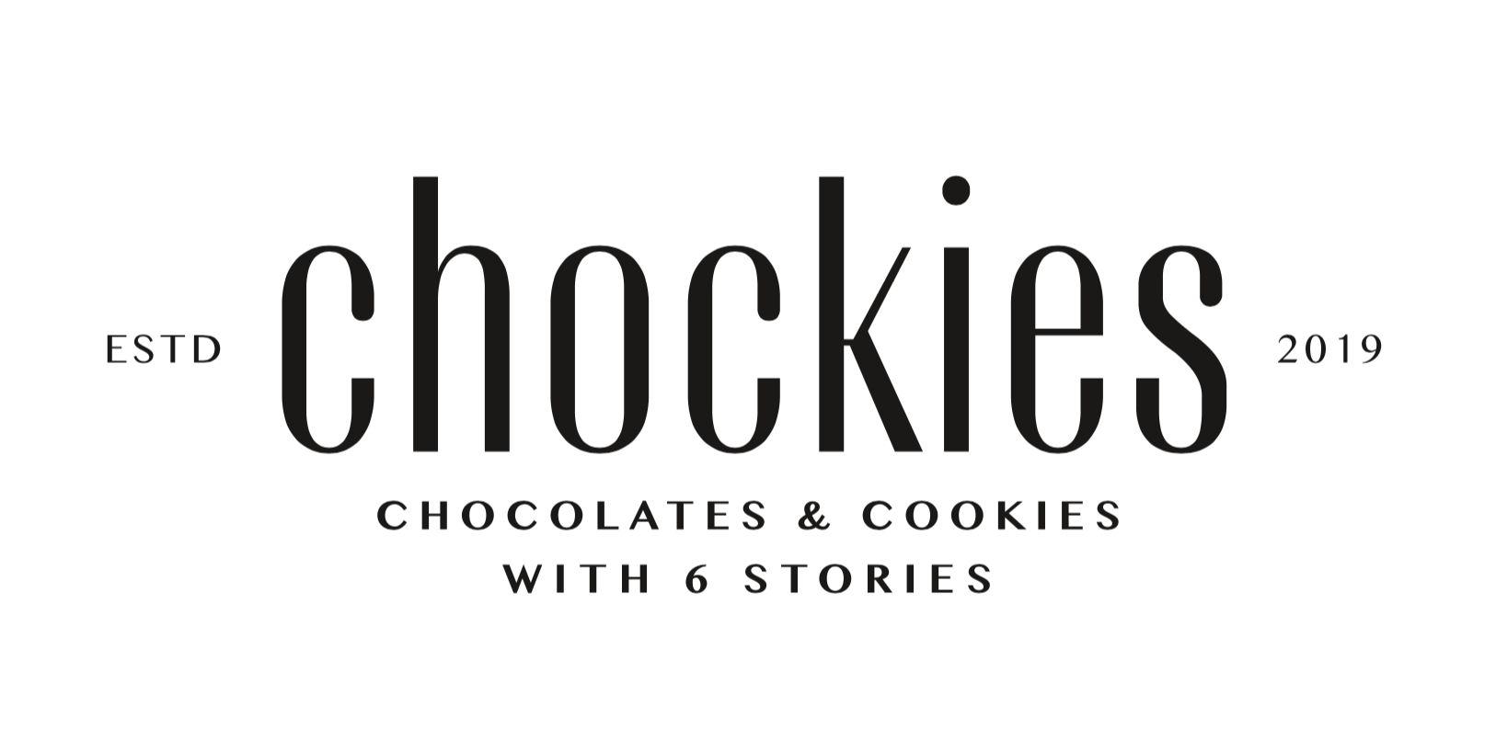

Text#1
Assorted chocolate & cookies mixed with 6 stories

Text#2
Flavor in package design:
Original
Matcha
Coffee
Tiramisu
Cheese
Strawberry

Taste The Fusion!

Text#3
Ingredients:
Sugar, Full cream milk powder, matcha powder, strawberry powder, coffee powder, Cheese powder, tiramisu powder, Cocoa butter, Wheat flour, Vegetable fatx, Cocoa mass, Emulsifiers, Cocoa, Yeast, Flavours, Salt.

Text#4
Product of Indonesia

Production date
17 July, 2019

Expired date
17 July, 2021

M2_Recycle Logo
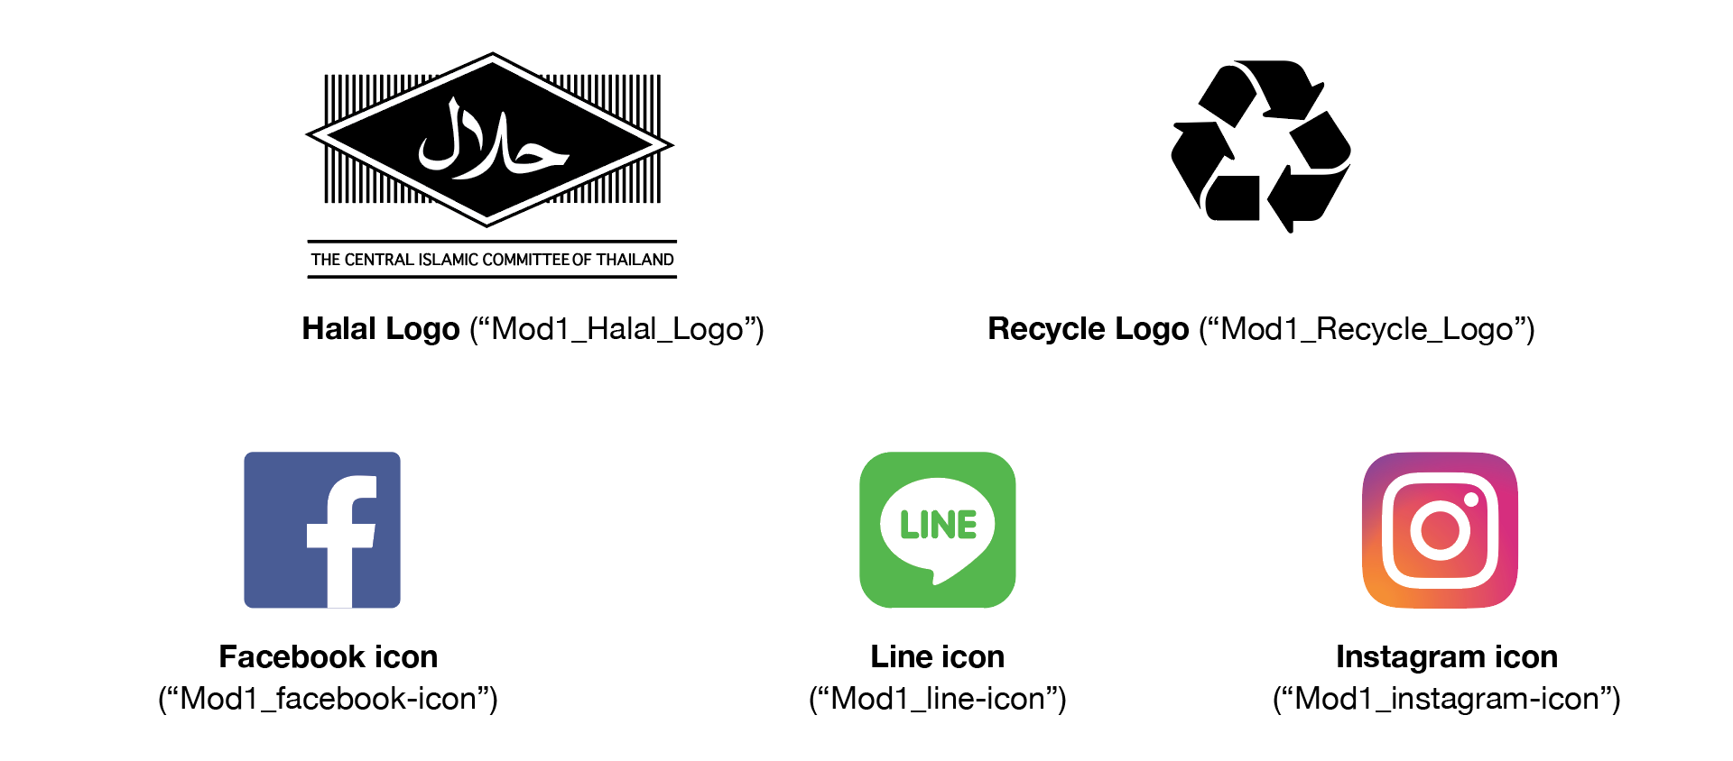

Barcode
